# Problem 0. Briefly and clearly report what you have done for Homework Assignment #4.

## Problem1

Sudo fdisk –l >after.txt

Sudo fdisk –l >before.txt

Diff after.txt before.txt

We can find it mount on /dev/sdb1

## Problem2

Hostname查看主机名字Hostnamectl可用于查询和更改系统主机名和相关设置

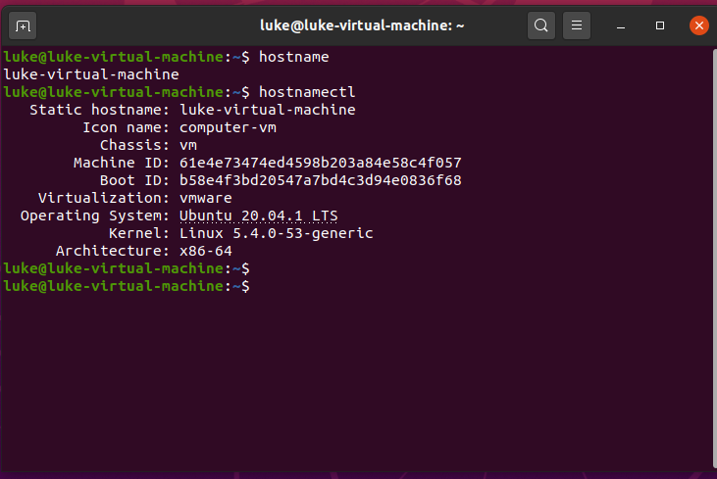

sudo hostnamectl set-hostname linuxconfig

修改文件/etc/hosts, 这样重启也依旧是更改后的名字

## Problem3

Ssh 连接服务器, 我把demo_x.c传输上去. 然后修改成雨伞或者其他图标,display一下就可以了.

scp -P 11189 -r demo_x.c [root@117.93.33.92:/home/data](mailto:root@117.93.33.92:/home/data)

不用登录ssh也可以用scp把demo_x.c传输到117.93.33.92的/home/data/文件夹下,用户名为root

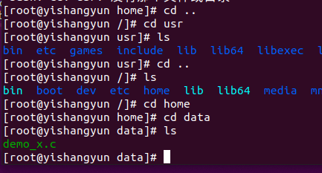

**gcc -o main demo_x.c -lX11 编译**

**修改服务器和客户端的ssh配置文件**

xhost +　　//允许服务器的的x11界面连接过来  
ssh -P 11189 -X root@117.93.33.92　　　　　　//-X参数表示转发X11数据

然后就可以运行程序

xclock

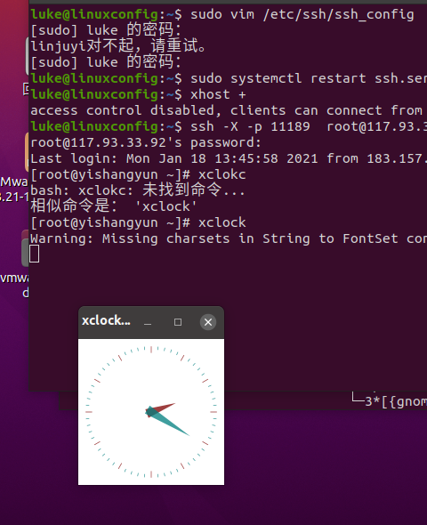

修改代码如下,即可显示雨伞

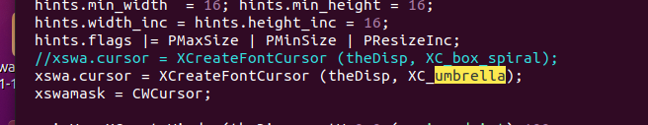

## Problem4

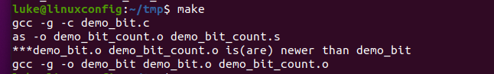

the purpose of the result program. : turn the input into hexadecimal number

and count how many bits of this number is 1;

## problem5

make and display

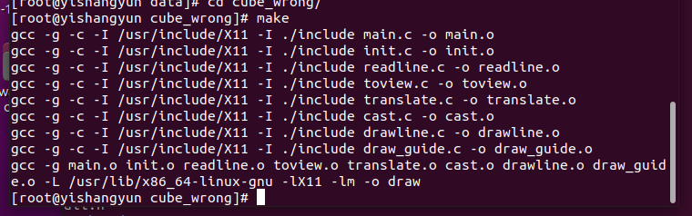

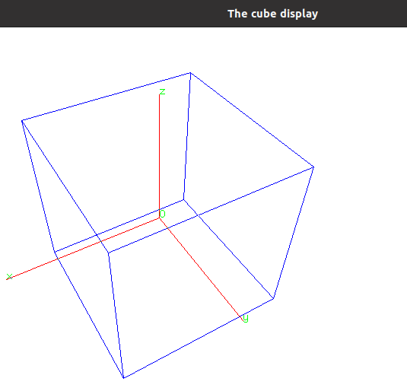

the reasons for compiling warnings

1. don’t have the header file

2. don’t have correct number of arguments

# Problem 1. Build 'demo_fork.c' and run it, then try to change the red eyes to 'browse.tcl' and run it again.

通过C代码启动tcl?

错误1 Gcc demo_fork.c

不能执行 a.out

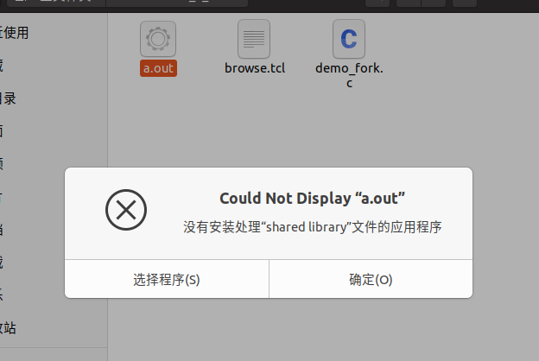

解决方法:

终端中打开,成功

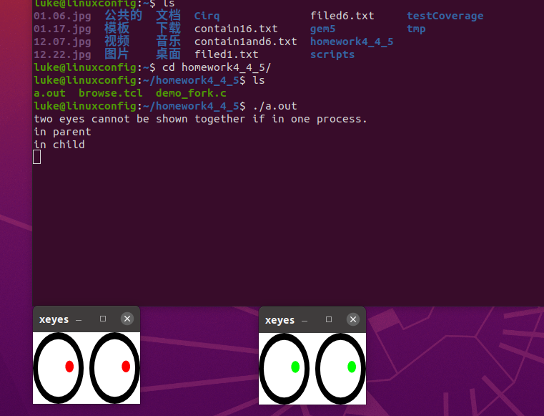

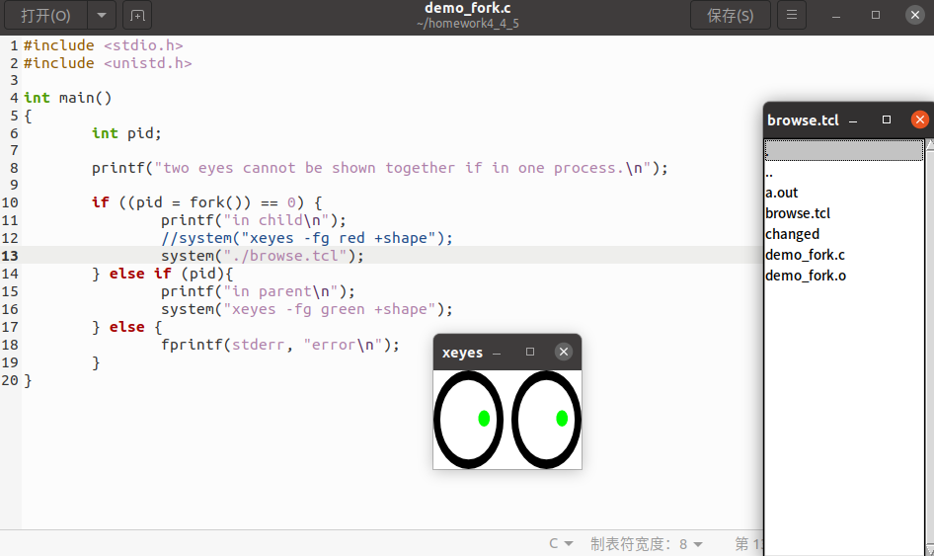

成功把红眼睛改为browse.tcl'

错误2 : bash: ./browse.tcl：/usr/bin/wish：解释器错误: 没有那个文件或目录

解决方法: apt-get install -y wish ,就可以了.

Invoke more directory browsers from browse.tcl. Use 'pstree' to see the process hierarchy for all of them,

再点击一个目录就可以了and show the hierarchy with a screenshot.如下图

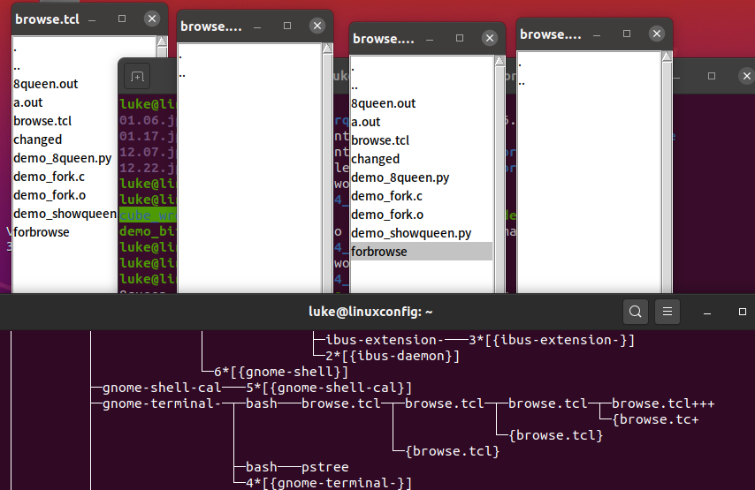

Problem 2. Run Python scripts of demo_8queen.py and demo_showqueens.py,

read the source code, comments and their outputs.

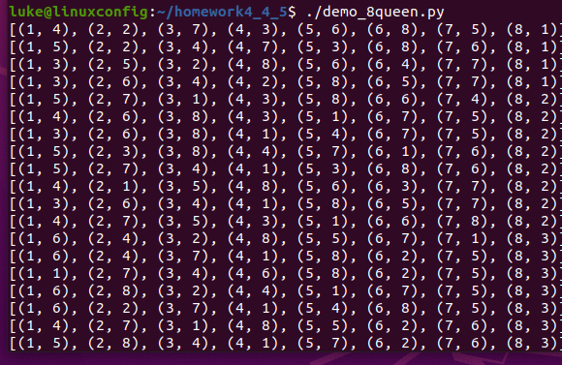

输出到8queen.out即可

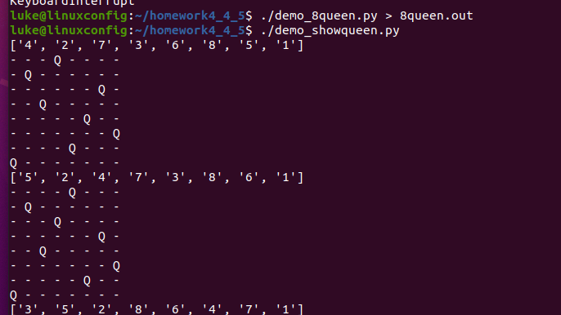

Then (OPTIONALLY) write a Perl or Python script to analyze the solutions in 8queen.out,

and show how many kinds of the solutions are unique.

(symmetrical solutions are not considered as unique, for example, one solution being mirrored or rotated should be eliminated from the unique list)